10 Success Factors for the Maintenance of Intralogistics Systems

- Intralogistics specialist TGW has created a formula for success derived from numerous customer projects
- The Austrian solutions provider has more than doubled the number of its customer service employees since 2015
- Growing focus on total costs over the entire life cycle
From the early enlistment of experts to data analysis to ongoing product development – the Austrian systems integrator TGW has identified ten success factors for the maintenance of intralogistics systems. An international team of service experts from the TGW Group under the leadership of Christoph Knogler, Director Global Lifetime Services, has worked together with customers to identify those key factors that will ensure long-term success. “Still, there is no single approach that is right for everyone,” emphasizes Christoph Knogler. “Intralogistics systems differ from each other in terms of function and complexity. And so the operating and maintenance requirements differ as well. However, there are some influencing factors that you should definitely pay attention to.”

As service has become an increasingly important issue, TGW has more than doubled its customer service staff since 2015. As a globally active company, TGW offers innovative service concepts which are presented to the customer at an early stage of a project. An individual package is then put together. “Total cost considerations over the lifecycle of a plant are becoming more and more important – and, along with that, total cost of ownership. These must be mutually optimized,” says Knogler.

The 10 factors of success at a glance
1. Involve experts at an early stage
2. Develop an appropriate maintenance strategy
3. Create transparency
4. Make costs predictable
5. Create win-win situations
6. Foster awareness and responsibility
7. Use technology effectively
8. Analyze data for continuous improvement
9. Proactively prevent unpleasant surprises
10 Ongoing further development means retrofitting

The 10 success factors in detail

1. Involve experts at an early stage: Operating and maintenance concepts as well as the costs need to be assessed and taken into account from the very beginning of the project. The early involvement of experienced experts on the part of all partners (clients, potential contractors and suppliers, consultants) allows for the evaluation of various system solutions according to operating expenses.

2. Develop an appropriate maintenance strategy: Who ensures the availability of a particular intralogistics solution? This pivotal question needs to be raised and answered at an early stage of the project. In many cases, the clients' corporate strategy decides whether they want to be responsible for operational maintenance themselves or outsource it to partners. The tendency for customers is to focus on their core competencies and to entrust maintenance to intralogistics specialists.

3. Create transparency: Service Level Agreements (SLAs) and so-called RACI definitions (Responsible, Accountable, Consulted, Informed) should be established in a responsibility matrix at the very latest after the plant's service partners have been determined. The SLAs should outline expectations with regard to the extent of fault processing and include the agreed-upon response times. The RACI matrix determines who is responsible for which tasks.

4. Make costs predictable: While it is impossible to safeguard a business against all contingencies, so-called full-service packages allow service spending to be set over a certain period of time. The configuration of these packages should be carried out in the interest of the project partners and may include spare parts consumption, on-site and remote services. The underlying principle is a clear definition of the services to be provided. Service partners are under obligation to take care of these issues in cooperation with the service organization.

5. Create win-win situations: The partnership of all project participants is closely related to the responsibility that both or several parties bear for the operational operation of the intralogistics facility. Essential elements of an ideal cooperation are the cultivation of a good relationship as well as a candid approach to problem solving. Mutual success, as well as mutual failures, inspire improvement strategies that are developed and implemented by the team as a whole.

6. Foster awareness and responsibility: The decisive factor here is the set-up of the support organization. It is imperative to define clear responsibilities within the team, to define escalation strategies and to check these for compliance on a regular basis. Responsibility also includes the distinctly defined task of identifying improvement potential and implementing projects according to the principle of continuous improvement processes (CIP). Each individual team member needs to be aware that the common mission is to continuously improve the plant and to adapt it to new developments.

7. Use technology effectively: Valuable insights for improvements can be gained from fault analyses and recorded maintenance data. But this requires the proper tools. Digitization offers a multitude of solutions in this regard. It is therefore essential to identify and use the appropriate tools. Maintenance planning systems (such as TGW CMMS), visualization and monitoring tools, and digital assistance systems are just a handful of examples of how cutting-edge technology can make service teams much more effective.

8. Analyze data for continuous improvement: Automated systems produce large amounts of data. These must be interpreted, filtered, consolidated, and evaluated and then useful conclusions must be drawn. Ideally, the project partners will control data flows in such a way that they can make quick decisions in their day-to-day work after an analysis. Predictive maintenance, condition monitoring, and database analysis (data mining) are the catchwords in this context.

9. Proactively prevent unpleasant surprises: In this regard, professional handling of workload peaks is of particular importance. Peak seasons, such as Black Friday in the USA or the Christmas season, should be defined as separate projects for which teams must prepare. It may well happen that the need for personnel will temporarily increase at a specific location. In addition, preventive maintenance in critical areas of the plant may be necessary before the high season begins.

10. Ongoing further development means retrofitting: An intralogistics system is designed for a specific requirement profile, which is usually based on the client's business prediction. At the time of plant start-up, this forecast has either already come true or the next optimization potential has already been identified. Retrofit and upgrade actions help realign the plant to these new conditions.

Lifetime Services Video
That’s how TGW masters the challenges with its diversified product range.
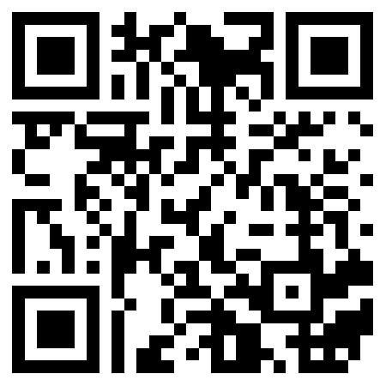
www.tgw-group.com
About TGW Logistics Group:
TGW Logistics Group is a worldwide leading provider of intralogistics solutions. For 50 years this Austrian specialist has been providing automated systems for international customers from A as in Adidas to Z as in Zalando. As a systems integrator, TGW provides planning, production, and implementation of complex logistics centers –from mechatronics to robotics and from control systems to software solutions.

With approximately 3,300 employees, TGW Logistics Group has offices in Europe, China, and in the U.S.A. In the 2017/2018 business year the company achieved a total turnover of € 713 million.

Reprints:
Images reprinted for press reports featuring primarily TGW Logistics Group may be used free of charge and under citation of the source. No free reprints for promotional purposes.

Contact:
TGW Logistics Group GmbH
A-4614 Marchtrenk, Ludwig Szinicz Strasse 3
T: +43.(0)50.486-0
F: +43.(0)50.486-31
E-Mail: tgw@tgw-group.com

Press contacts:
Alexander Tahedl
Marketing & Communications Specialist
T: +43.(0)50.486-2267
M: +43.(0)664.88459713
alexander.tahedl@tgw-group.com

Martin Kirchmayr
Director Marketing & Communications
T: +43.(0)50.486-1382
M: +43.(0)664.8187423
martin.kirchmayr@tgw-group.com

