PRESS CONFERENCE 2014/2015

**Speaker**

**Georg Kirchmayr**President of TGW Logistics Group

**Outline:**

* Business results of the fiscal year 2014/2015
* Successful strategy
* Positive outlook on 2015/2016
* Market trends in the industry
* Excellent projects
* International focus – Growing company
* Employees wanted

Wednesday, 4th November 2015 in Linz

Thursday, 5th November 2015 in Vienna

Pictures of the press talk available on

[www.apa-fotoservice.at](http://www.apa-fotoservice.at)

Press text (German) available on

<http://pressecenter.reichlundpartner.com/News.aspx?menueid=5533>

**TGW Logistics Group’s international growth plan**

**Double-digit growth and 330 new employees wanted**

**Wels, 4th November 2015 –** The TGW Logistics Group headquartered in Wels, Upper Austria, is a worldwide leading provider of highly dynamic, automated and turnkey logistics solutions. Since 1969 the international company group has implemented material handling solutions for leading companies in many industries such as H&M, Esprit, Jack Wolfskin, Mango, Coop, Kaufland, Banner Batterien, Conrad, Thomann, Amazon or Kärcher. About 2,500 employees are working daily on the technologies for high-tech e-commerce solutions and support TGW customers in their success.

**Successful strategy**

In the business year 2014/2015, the TGW Logistics Group generated a revenue of 475 million Euros, which means a growth of 28.17 per cent within one year. “The year 2014/2015 was very successful for our company,” explains Georg Kirchmayr, President of TGW Logistics Group. “We have pursued a clear goal during the past years and we achieved it. We developed from a supplier of mechanical equipment and installations to a systems integrator and are successful with our portfolio all over the world.” The numbers proves Kirchmayr’s statement right: Beside the pleasant growth in revenues, also the number of employees has risen to about 2,500.

Furthermore, the Group is happy to have left marks on various markets. “In the year 2000, the company was exclusively active in Germany and Austria, today TGW fulfils worldwide orders with entities in 15 countries and production facilities on three continents. In 2015, we were able to open our own production facility in China,” Kirchmayr says. “The entire expansion was financed from our cash flow.”

**Key figures**

|  |  |  |  |  |  |  |
| --- | --- | --- | --- | --- | --- | --- |
| Business year | 2015/2016  Plan | **2014/2015** | 2013/2014 | 2012/2013 | 2011/2012 | 2010/2011 |
| Revenues in million Euros | 570 | **475** | 370.6 | 388.9 | 362.3 | 296.8 |
| EBIT in million Euros |  | **29.2** | 15.4 | 16.2 | 17.9 | 18.4 |
| Group employees |  | **2,350** | 2,000 | 1,750 | 1,600 | 1,350 |
| R&D in million Euros |  | **10.8** | 7.8 | 7.5 | 6.3 | 6.2 |

**Positive outlook on 2015/2016**

Georg Kirchmayr is confident for the business year 2015/2016, too: „We expect a further positive development. At the beginning of the current business year, already 70 per cent of our operating performance were set. This means safety for the following year, and we already establish the basis for the year after.”

One of the most important drivers for the company is online retail. “We have dealt intensely with the e-commerce topic, carried out studies and cooperate with universities. We know what we do and are therefore able to provide our customers with optimum solutions for their successful future. We know the business and the market trends, and with accurate planning and close teamwork with our customers, we find the ideal solution. This way, we convert the challenges of online retail into IT strategies and assure the operation.”

**Market trends in the industry**

The demand for material handling solutions is unbroken, even in the various markets. “In the US we see great potential, especially concerning e-commerce. We have big expectations regarding China. Even if only half of what we expect will be achieved, it will be a great success,” says Georg Kirchmayr. At the moment, the mood in Europe is a bit low, which is also reflected in the economy. “However, we are very satisfied with our European entities. Especially with England, where the focus is on e-commerce similar to the US. We can celebrate great successes there.” The market in South America is currently rather difficult, as “many countries face a structural crisis.”

**Excellent projects**

The TGW logistics centre for the Swiss grocery giant Coop at their site in Schafisheim will be opened in 2016. In the largest building site of Switzerland, TGW implements an extensive and complex logistics installation consisting of four parts. All kinds of groceries are stored and conveyed in different areas. A high bay rack for pallets and totes, for dry, fresh and frozen goods will be realised within a highly dynamic TGW solution. Furthermore, TGW was able to win a comprehensive service contract for the gigantic Coop distribution centre.

**adidas do Brasil** will soon receive the latest logistics technologies at their site in Embu das Artes, near São Paulo. In Brazil, TGW implements the distribution centre for the Olympic Games 2016 in Rio, which will serve the Brazilian market with an individual picking system for adidas. The technology including 2.1 kilometres of complex conveyor equipment as well as the software will be supplied by TGW. Additionally, TGW offers adidas a Lifetime Service package to supply all relevant spare parts and take care of maintenance including 24/7 hotline service for two years.

The new **Mango** distribution centre was built in Palau Solità de Plegamans, Barcelona. The Spanish fashion chain relies on TGW technology for the replenishment of more than 4,000 stores: the new logistics centre will combine the handling operations for flat garments, pre-configured assortments and hanging garments for store replenishment. Due to the continuous growth and the introduction of new labels, the number of international shops and products is permanently increasing. TGW Logistics Group offered Mango the ideal and cost-effective solution in order to pursue their growth strategy with minimum personnel effort.

**International directions – Growing company**

The worldwide success of TGW Logistics Group demands the expansion of the headquarters in Wels: During the next three years, a new building with a surface of 10,000 square metres will be established on a 75,000 square metre area. “As logistics specialist, we always keep our future in sight”, says Kirchmayr. “We planned the project to be able to expand our offices afterwards. With the new building in Marchtrenk, we are only a stone’s throw away from our existing office building. In 2018, 400 TGW employees will move into the office building, and an additional 200 employees from the production area will work there.”

Internationality is one of the major aspects for TGW – not only for the company’s growth. “Our experts work in entities in Europe, America and Asia. They are close to the customers and respond to their needs. TGW employees come from more than 40 nations and work in 15 countries worldwide. The diverse cultures that are united in the company group promote the increase of tolerance. Due to the present variety of languages, our employees are always motivated to improve their skills, also regarding foreign languages.”

**Employees wanted**

In order to be prepared for the rapid company growth, the TGW Group is searching for 330 new employees. “For new exciting projects and our further success path, we are searching for colleagues especially in the fields of mechanical engineering, mechatronics, automation and controls technology, software development, assembly and commissioning with technical education, technical college or university degrees,” says Georg Kirchmayr. “TGW’s employees are working all around the world, at the moment we are recruiting predominantly for the German-speaking regions, the UK, the US and China. For our headquarters in Wels, we are looking for 180 new colleagues.” Current vacancies and job profiles are available on [www.tgw.jobs](http://www.tgw.jobs).

www.tgw-group.com

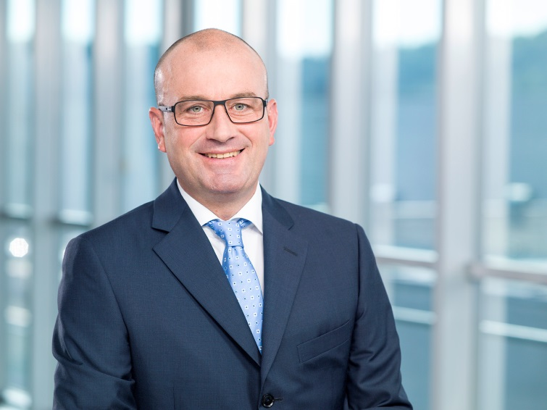

**Caption:** “The TGW Logistics Group is growing internationally,” Georg Kirchmayr, President of TGW Logistics Group, is happy. “In the business year 2014/2015, the company generated a revenue of 475 million Euros, which means a growth of 28.17 per cent within one year. In order to prepare ourselves for the rapid growth, we are searching for more than 330 new employees.”

**Pictures:**

Reprint with reference to TGW Logistics Group GmbH free of charge. Reprint is not permitted for promotional purposes.

**Contact:**

TGW Logistics Group GmbH

A-4600 Wels, Collmannstraße 2

T: +43.(0)7242.486-0

F: +43.(0)7242.486-31

E-Mail: tgw@tgw-group.com

**Press contact:**

Martin Kirchmayr Daniela Nowak

Marketing & Communication Manager Marketing & Communication Specialist

T: +43.(0)7242.486-1382 T: +43.(0)7242.486-1059

M: +43.(0)664.8187423

martin.kirchmayr@tgw-group.com daniela.nowak@tgw-group.com